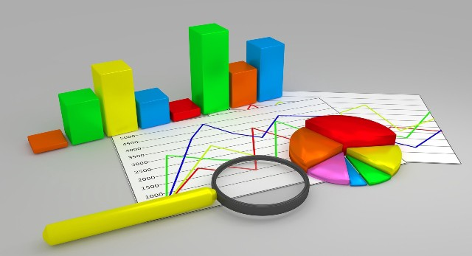

**Group Members (Group # 8):**

**Ali Khalid MSDS21001**

**Muhammad Ahmad MSDS21021**

**Muhammad Tayyab MSDS21032**

**Haider Ali Adeel MSDS21044**

Citation Analysis of Pakistani Researchers in the Field of Data Science

**Data Collection: Questionnaire**

Our project doesn’t require data to be collected from people. In this project we will be scraping data from online resources. The attributes of the data we will scrap for our projects are as follows:

1. **Authors:**

This filed contains abbreviated names of all the authors of publication.

1. **Authors Full Name:**

This filed contains full names of all the authors of publication. This filed is required as two authors having different full names can have save abbreviated name.

1. **Document Title:**

This attribute contains the full title of the publication.

1. **Publication Name:**

This attribute contains the full name of the conference/journal where publication is published.

1. **Document Type:**

This attribute specifies the type of publication. The type can be a conference paper, book chapter, journal paper, article etc.

1. **Keywords:**

This attribute contains all the keywords specified in the publication.

1. **Abstract:**

This attribute contains the abstract of the publication.

1. **Author Address:**

This attribute contains address of all the authors.

1. **Email Address:**

This field contains email address of all the authors.

1. **Cited References Count:**

This filed contains the count of publications cited by the publication under consideration.

1. **Total Times Cited**

This attribute reflects the total numbers of citation of the publication.

1. **Total Times Cited (last 180 days)**

This attribute reflects the total numbers of citation of the publication for the window on past 180 days only.

1. **Total Times Cited (since 2013)**

This attribute reflects the total numbers of citation of the publication after the year 2013.

1. **Publisher**

This field contains the name of the publisher of the publication.

1. **Publication Year**

This filed contains the year in which publication was published.

1. **Publication Date**

This field contains the date (day and month) on which publication was published.

1. **Page Count**

This attribute contains the total number of pages of the publication.

1. **Subject Category**

This attribute contains the name of the subject/field which is most closely related to the publication.

1. **Research ID Number**

This field contains the unique identifier of the publication.

These are the fields which we consider will be useful for our analysis. We may add/remove fields with the progress of the project.